**Oracle for CS5322**

1 SSH to the VM (cs5322-15-i.comp.nus.edu.sg) with unix account **oracle** and password **adminSep2023**

2 To change password, after login do, issue command: passwd

3 To start oracle instance, do (the commands to enter are in bold):

[oracle@cs5322-15-i ~]$ **sqlplus**

SQL*Plus: Release 19.0.0.0.0 - Production on Tue Aug 16 22:43:18 2022

Version 19.20.0.0.0

Copyright (c) 1982, 2022, Oracle. All rights reserved.

Enter user-name: **/ as sysdba**

Connected to an idle instance.

SQL> **startup**

ORACLE instance started.

Total System Global Area 2801794952 bytes

Fixed Size 8900488 bytes

Variable Size 587202560 bytes

Database Buffers 2197815296 bytes

Redo Buffers 7876608 bytes

Database mounted.

Database opened.

SQL> **exit**

4 To start the listener, do:

[oracle@cs5322-15-i ~]$ **lsnrctl**

LSNRCTL for Linux: Version 19.0.0.0.0 - Production on 16-AUG-2022 22:46:30

Copyright (c) 1991, 2022, Oracle. All rights reserved.

Welcome to LSNRCTL, type "help" for information.

LSNRCTL> **start**

Starting /opt/oracle/product/19c/dbhome_1/bin/tnslsnr: please wait...

TNSLSNR for Linux: Version 19.0.0.0.0 - Production

System parameter file is /opt/oracle/product/19c/dbhome_1/network/admin/listener.ora

Log messages written to /opt/oracle/diag/tnslsnr/cs5322-15-i/listener/alert/log.xml

Listening on: (DESCRIPTION=(ADDRESS=(PROTOCOL=tcp)(HOST=cs5322-15-i.comp.nus.edu.sg)(PORT=1521)))

Listening on: (DESCRIPTION=(ADDRESS=(PROTOCOL=ipc)(KEY=PNPKEY)))

Connecting to (ADDRESS=(PROTOCOL=tcp)(HOST=cs5322-15-i)(PORT=1521))

STATUS of the LISTENER

------------------------

Alias LISTENER

Version TNSLSNR for Linux: Version 19.0.0.0.0 - Production

Start Date 16-AUG-2022 22:46:35

Uptime 0 days 0 hr. 0 min. 0 sec

Trace Level off

Security ON: Local OS Authentication

SNMP OFF

Listener Parameter File /opt/oracle/product/19c/dbhome_1/network/admin/listener.ora

Listener Log File /opt/oracle/diag/tnslsnr/cs5322-15-i/listener/alert/log.xml

Listening Endpoints Summary...

(DESCRIPTION=(ADDRESS=(PROTOCOL=tcp)(HOST=cs5322-15-i.comp.nus.edu.sg)(PORT=1521)))

(DESCRIPTION=(ADDRESS=(PROTOCOL=ipc)(KEY=PNPKEY)))

Services Summary...

Service "cs5322.comp.nus.edu.sg" has 1 instance(s).

Instance "cs5322", status UNKNOWN, has 3 handler(s) for this service...

The command completed successfully

LSNRCTL>

5 To stop the listener, do:

[oracle@cs5322-15-i ~]$ **lsnrctl**

LSNRCTL for Linux: Version 19.0.0.0.0 - Production on 16-AUG-2022 22:48:43

Copyright (c) 1991, 2022, Oracle. All rights reserved.

Welcome to LSNRCTL, type "help" for information.

LSNRCTL> **stop**

Connecting to (ADDRESS=(PROTOCOL=tcp)(HOST=cs5322-15-i)(PORT=1521))

The command completed successfully

LSNRCTL>

6 To stop oracle instance, do:

[oracle@cs5322-15-i ~]$ **sqlplus**

SQL*Plus: Release 19.0.0.0.0 - Production on Tue Aug 16 22:49:17 2022

Version 19.20.0.0.0

Copyright (c) 1982, 2022, Oracle. All rights reserved.

Enter user-name: **/ as sysdba**

Connected to:

Oracle Database 19c Enterprise Edition Release 19.0.0.0.0 - Production

Version 19.16.0.0.0

SQL> **shutdown immediate**

Database closed.

Database dismounted.

ORACLE instance shut down.

SQL>

7 To access oracle instance from an external client (sqldeveloper), configure as below:

- DBA account id is **system** and password is **cs5322database**

- Hostname is cs5322-1-i.comp.nus.edu.sg to cs5322-20-i.comp.nus.edu.sg

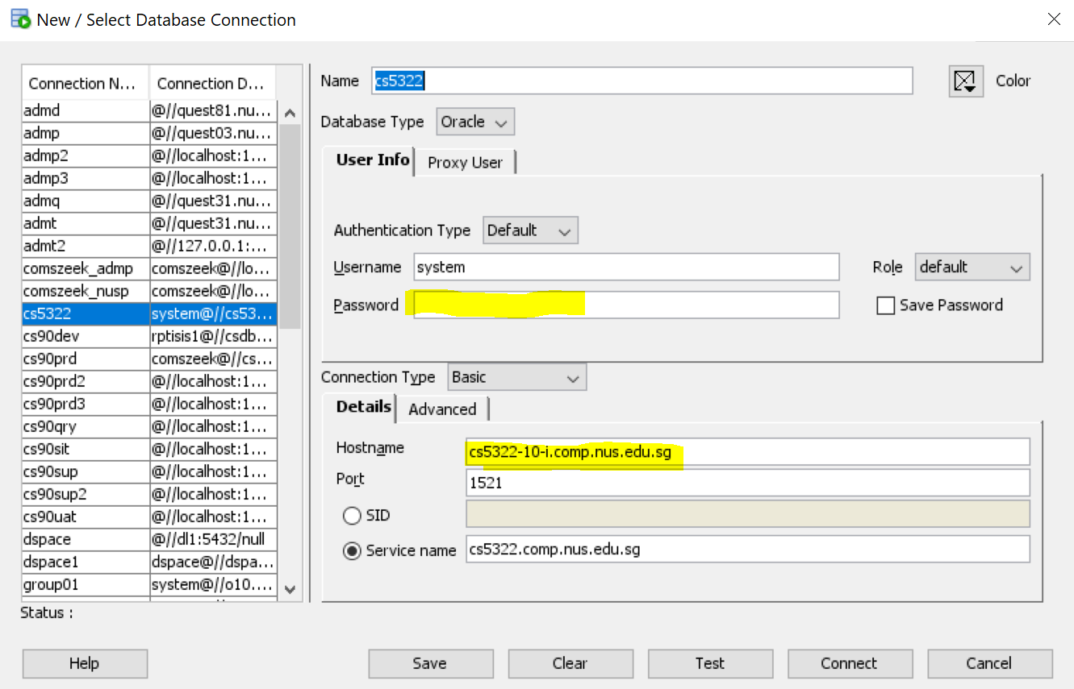

8 To change password for account system, do:

